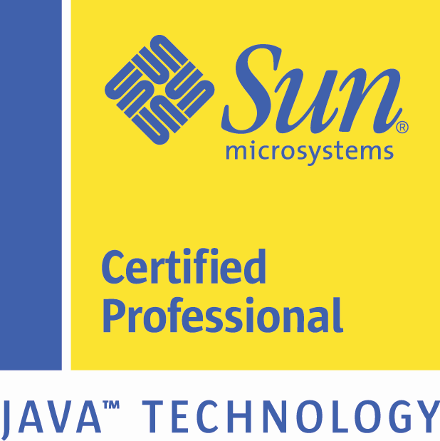
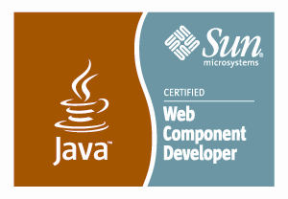
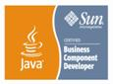

NISHANT BHARDWAJ
(Senior Certified Java J2EE Programmer)
Nishant.java7@gmail.com
573-202-0505

Senior Certified J2EE developer seeking J2EE web application consulting contract corp to corp project with a suitable client in California

KEY areas of work: Struts 1.2, JSF 2.2, J2EE 7, JSPs, Servlets, Business Objects, EJBs in J2EE web application project including work experience in Healthcare sector for Texas State Government federal project

Profile:
- 7 years of IT Experience
- 7 years of Java /J2EE Experience

Summary:
- SDLC: 7 years of software development experience in object oriented programming, design and development of Multi-Tier distributed, Enterprise applications using Java and J2EE technologies with Software Development Life Cycle.
- Core Java/J2EE: 7 years of Programming experience in Java 2.0, JDK 1.7,1.6,1.5,1.4, J2EE 7, 1.5,1.4, J2SE, EJB 3.0,2.0 (Entity, Session Beans), Beans, Servlets, Applets, JSP, RMI, AWT, JDBC, HTML, DHTML, SOAP, Unix Shell Scripting, Middleware technologies including web Methods.
- Web Servers: 4 years of extensive experience in Programming, Deploying, Configuring, Fine-tuning and Administering Application & Web Servers such as Rational Application Developer 7.5, Application Server, IBM Websphere 7.0/ 6.0, IBM Websphere Studio Application Developer (WSAD) 5.0/4.0 and BEA Weblogic 9.2/10.
- XML: Strong XML experience using XML 1.0, XSL, XSLT, DTD Schema & SAX/DOM, AJAX, HTML, DHTML, CSS and JavaScript. Experienced in parsing (DOM and SAX) XML using JAXP API. Experience with JAXB for marshalling and unmarshalling xml.
- Environment: Experienced with RDBMS implementation and development using Oracle 11G, 10G/9i/, MS SQL Server 2005/2000, DB2 on Windows 95/98/NT/2000/XP, and Fedora Core Linux.
- Architecture: Experience in Service Oriented Architecture (SOA), Struts Framework, Spring Framework, Hibernate, J2EE Design Patterns, Arquillian Testing Framework, and MVC.

CERTIFICATIONS
- Sun Certified Programmer for the Java 2 Platform, Standard Edition 1.4 (CX-310-035)
- Sun Certified Web Component Developer for J2EE 1.4 (CX-310-081)
- Sun Certified Business Component Developer for J2EE 1.3 (CX-310-090)

Technical Summary
Java | Java 7/6/5/2.0/1.1/, JDK 7/6/5/2.0/1.4/1.3, J2EE 7.0/2.0/1.1, EJB 3.0/2.0, GoF and J2EE Design Patterns, JNDI, JWS, JSP, Servlets, Java Beans, Applets, Swing, AWT, JDBC, Rational Rose 2000, Soap, WSDL, JSF 2.2, PrimeFaces 5.1
Enterprise Servers | IBM Websphere 7.0, IBM Business Integration Broker, BEA Weblogic 8.1/, BEA Weblogic Integration 8.1, JBoss Application Server 5.0 , Apache Tomcat 6.0, WildFly 8X server
XML Technology | XML, XSL, DTD/Schema, Apache Xalan (XSL processor), Apache Xerces (XML parser), JABX , Castor, XSD, WSDL, SOAP UI
Programming | SQL, PL/SQL, HTML 4.0, DHTML, JavaScript, UNIX Shell Scripting, Struts1.2/2.0, JSP/Servlets, Spring 3.0, WebMethods
Databases | MS Sequel Server 2005, Oracle 11G,10g/9i/8i, Mysql 5.1,4.x,2, DB2
Other Tools | WSAD, JBuilder, Eclipse, Rational Rose, TOAD, VSS, CVS, UML, log4J, Apache Ant, Apache Maven
Environment | UNIX (Linux), Fedora Core Linux, MS-DOS, Windows 98/NT/2000/XP
Network | TCP/IP, HTTP, SNMP, CLI
Languages / API’s | Java, JSP, HTML, XHTML, CSS, DHTML, Log4j, Tiles, C, UML, AJAX, JSTL, SQL, PL/SQL, Web Services SOAP, REST Jax-RS

PROFESSIONAL EXPERIENCE

Software Developer Dec 2014-Till Date
Mississippi State Government (via Remote client location in California)
Irvine, CA
Web Application Conversion Project

Description:
This web Application conversion project has 2 parts to it
- Development of testing tool using Arquillian framework which will test the newly converted JSF 2.2 pages using its automated testing framework
- Development of tool to convert from Struts 1.2 to JSF 2.2/Prime faces 5.1

Responsibilities:
- Presently working on web application migration project for Mississippi State Government end client
- Worked on software development of automated testing tool using Arquillian framework for doing functional testing of newly converted JSF web pages
- Integrated the Graphene2 and some of its key components including PageObjects and PageFragments to this testing tool
- Integrated PrimeFaces to this new arquillian graphene testing tool software
- Worked on Mapping document to convert Struts 1.2 tags to JSF 2.2/Prime faces 5.1 tags.
- Worked on software development of the conversion tool for this project involving PMD AST transformation API
- Coded for various tags for this conversion project including Struts tag html:text, html:textarea, html:hidden, html:checkbox, html:submit to equivalent Primefaces.JSF tags.
Environment: java 1.7, java EE7, JSF 2.2, PrimeFaces 5.1, Struts 1.2, GIT, WilfFly 8X Server, Eclipse Luna, Oracle 11g, HTML, JSON, Junit, Arquillian Testing Framework, WebDriver API, PMD AST 5.1 API.

Software Developer Mar 2012-Nov 2014
Texas State Government (via Deloitte Consulting LLP)
Austin, TX
Texas Integrated Eligibility Redesign System

Description:
TIERS is a state-of-the-art state eligibility system that administers programs such as Medicaid, TANF, and SNAP. This project is for Data Collection, which is largest functional area in TIERS which allows the HHSC (Texas Health and Human Services System) worker to record detailed client information

Responsibilities:
- Presently working on software development consulting project for Texas State Government end client
- Developing backend and front end of high volume transaction TIERS Data Collection project
- Involved in backend and front end application development for Data Collection LUWs
including Appointments, Disability, Application Registration- Register Program, Program Denial, Application Denial, Undo Initiate Review; Inquiry –Individual Summary LUW; Data Collection Batch process for processing Referrals to FFE (Federal Facilitated Exchanges)
- Developing and supporting the Data Collection online system throughout the development life cycle
- TIERS is a state-of-the-art state eligibility system that administers programs such as Medicaid, TANF, and SNAP
- Coded for building verification checklist links (VCLs)
- Co-coordinated with various teams for inter dependency software issues
- Documented Change Request Document(CRD) for my projects
- Conducted basic testing for projects using SOAP UI test cases.
Environment: java 1.6, java EE 5.0, EJB 2.0, JSP 2.0, Servlets 2.5, Rational Application Developer 7.5, WebSphere Application server 7.0, ClearCase 8.0, Oracle 11g, PL/SQL Developer 8.0, JDBC 4.0 , JavaScript 1.2, HTML, CSS, JQuery 1.4

Software Developer Dec 2010-Feb 2012
Dish Network (via Wipro Technologies)
Denver, CO
Business Transformation Project

Description:
The client Dish Network is a Television company. This project was based on transforming project from present billing system to new SOA standard billing system.

Responsibilities:
- Worked on java based Web Methods Development for this BT project
- Researched and developed software for ClubDish billing application.
- Coded for migration of Tax using CSG transactions.
- Programmed software for AccessoryManagement module
- Developed software for WildBlue application
- Developed front end and back end for Bundled Product Service
- Co-coordinated with various teams for inter dependency software issues
- Documented Technical Requirement Documents(TRD), Test Case Design(TCD) documents for my projects
- Conducted basic testing for projects using SOAP UI test cases.
- Developed XSDs and WSDLs for various SOA based operations
- Co-ordinated with App Management team for batch development support.
Environment: JDK 1.5, Web Methods 8.2//8.0, Unix, Oracle 10g, XML, Web Services, Apache Axis, SOAP UI, PL/SQL, XML, XSD, WSDL, SVN, SOA, Web Service, SQL Server

J2EE Developer Mar 2010-Oct 2010
Cisco Systems, Inc. San Jose, CA
Network Profiling Project

Description:
The client Cisco Systems is a networking company. This project was based on network profiling project for their high profile customers. This includes proofing information related to switches, routers in customer’s network.

Responsibilities:
- Worked on J2EE Development for Network Profiling Project
- Implemented Backend Development involving Struts MVC framework
- Used Hibernate as persistence layer to interact with Oracle database and wrote the mapping files and configuration files.
- Developed Jboss Rule Runner Module
- Completed development of Device Meta Data Populator Sanitizer module using JDom Xpath, and Regex
- Contributed to the software development project involving XML work using JDOM API
- Transferred knowledge relating to Jboss Rule Runner to other members of team
- Developed complex business logic using Jboss Drools Rule Engine
- Updated System Documentation on Jboss Drools Project
- Used JUnit for unit testing the application.
- Updated Oracle DB using Toad
- Worked on multiple projects simultaneously

Environment: JDK 1.5, Jboss Application Server 5.1, CVS, Oracle 10g, XML, Struts 2.0, Java Servlets, JSP, Hibernate, Java Script, HTML, Web Services(SOAP), WSDL, Ant, PL/SQL, TOAD, Unix Shell Scripts, Windows 2003 Advanced Server, DHTML, JavaScript, AJAX, XML

J2EE Developer May 2007- Jan 2010
Nox Solutions Los Angeles, CA
e-commerce Projects

Description:
Nox Solutions is an Ecommerce Company which maintain e-commerce website of various media clients including Bill Oreilly, LeatherUp, Connoisseur Media, Dennis Miller, Larry King. This involved multiple backend projects involving maintenance and new feature enhancements.

Responsibilities:
- Worked on server side J2EE web applications using Struts MVC framework
- Under general supervision, designed, tested , and implemented web applications
- Developed ecommerce integration project involving Checkout by Amazon, this involved integrating our shopping cart with amazon checkout using amazon checkout APIs.
- Researched and contributed in integration of web based image application, this involved backend saving of the image received from the online image editing tool.
- Used Struts Framework, JSP, Java Script, DHTML, HTML for developing presentation layer
- Conducted Unit Test on web application involving Snipshot
- Transferred knowledge and transition work to team for various back end projects
- Worked on various back end projects for various websites involving server side issues including sql queries, database updates, inserts, and creation
- Developed complex business application logic for amazon project using java amazon api
- Deployed amazon project, snipshot project on Jboss Java EE Application Server
- Worked on backend session issues for these websites
- Developed Session Bean EJB for payment module.
- Updated System Documentation on snipshot API project
- Worked on multiple projects simultaneously prioritizing the tasks using JIRA software

Environment: JDK 1.5, J2EE, Java Servlets, JSP, EJB JBuilder, Jboss Application Server 4.0, CVS, MS Sequel Server 2005, T-SQL, JavaScript, Struts 1.2, EJB 2.0, DHTML, JavaScript, AJAX, XML

EDUCATIONAL QUALIFICATION

Master of Science (M.S) Missouri Science and Technological University, USA
Bachelor of Engineering (B.E.) Nagpur University, India

